INFOPACK

“APTSA”

Training Course “Another Gender of Sport”
PLACE AND DATE: Rijeka, March 17-25 2018
PARTICIPANTS: 20 (4 per partner country)
COUNTRIES: Croatia, Italy, Bulgaria, Peru and Brazil
LANGUAGE: The official language of the project is English.

The Training Course “Another Gender of Sport” is a second activity (first of two Mobility Activities) of the long-term project “A Path to TranSportAction”, a Capacity Building in the frame of Youth with 5 NGOs from Croatia, Italy, Bulgaria, Peru and Brazil.
Format TC will provide youth operators with knowledge, skills and NFE tools in order to involve local youth targets (females and males) in educational activities based on Sport and NFE to convey awareness and competences fostering female participation in Sport, rejection of gender stereotypes and respect of gender differences and sensibilities among young people in local rural communities and local rural communities as a whole.

ACTIVITIES AND METHODS:
Sport methodologies, in connection with NFE methods (Ice-breaking, Team Building sessions, Presentations, Outdoor Activities, NFE Workshops from the Salto and Compass Databases, Sport Workshops, Roundtables, Debates, Evaluation Groups, Case Studies, Study-visits, Team-work for the joint elaboration of NFE tools and list of best practices in the field of Sport education for promoting gender equality and fighting gender-based stereotypes).

ORGANIZERS AND FACILITATORS
The main organizers will be the RIJEKA SPORT’S ASSOCIATION and Mine Vaganti NGO composed by Mrs. Verica Mance and Mr. Roberto Solinas.

PARTNERS:
The activity will host 20 participants. Each organization will send 4 participants/ youth workers and leaders aged 18-25. Participants of the Training Course should have a bigger knowledge of English language, at least B1. Participants of TC are from the following countries:

Croatia: RIJEKA SPORT’S ASSOCIATION

Italy: MINE VAGANTI NGO

Bulgaria: BULGARIAN SPORTS DEVELOPMENT ASSOCIATION

Peru: BRIGADA VOLUNTARIOS BOLIVARIANOS DEL PERU

Brasil: ICYE

TRAVEL COSTS
According to new Erasmus Plus rules, the reimbursement of travel costs for participants will be calculated using the specific program called Distance Calculator:
Country | Maximum amount refundable per  participant
Italy | 275
Bulgaria | 275
Peru | 1100
Brazil | 1100

After sending their tickets and boarding cards, participants will receive the reimbursement of
their travel costs once the hosting organization.
Food, accommodation and local transports for activities will be fully cover by the project.

Please note: For participants from Peru and Brazil, the coordinating Organisation will book and pay all tickets in advance.

IMPORTANT! In order to buy a flight tickets as soon as possible, all partners are kindly asked to send names and copies of participant’s passport as soon as possible, latest till 25th of January 2018.

RESPONSABILITIES
Presentation of the original tickets with BOARDING PASSES and RECEIPT/INVOICES is obligatory.
Following the guide lines of the Erasmus + programme the travel must be realized by the participants on direct way within maximum 2 days before or after the project (this days ARE NOT COVERED BY THE PROJECT).
In case of longer stays or indirect travelling (holiday travel etc.) there is no chance of reimbursement of accommodation cost which will be covered from the night of 17th till the morning of 25th.
Please note if you bought your ticket in your local currency which might be different than EUR, we will calculate your travel costs according to the exchange rates from official European Commission website for the month of ticket purchase
http://ec.europa.eu/budget/inforeuro/index.cfm?Language=en

HOW TO REACH RIJEKA?

Venice, Trieste or Zagreb are the closest airport and all tickets will be bought accordingly.
- HOW TO REACH Rijeka from Milano/Trieste airport?
By train: Milano to Trieste and then from Trieste by bus to Rijeka https://www.autotrans.hr/en-us/choose-your-journey

- HOW TO REACH Rijeka from Zagreb airport?

By car
Travellers heading from Zagreb (185 km) should take the A1 to Bosiljevo and then take the A6 to Rijeka.
For detailed information on routes and costs take a look on the following site:
Via Michelin

By bus: from main bus station
https://www.autotrans.hr/en-us/choose-your-journey

ARRIVAL

If your flight should arrive when it is not possible to utilize the public transport, the host association will hire a means of transport (minibus) which cost (around 15 Euros) is charged on participants.

CURRENCY EXCHANGE
The Croatian Kuna is the currency of Croatia. Currency rankings show that the most popular Croatia Kuna exchange rate is the HRK to EUR rate. The currency code for Kuna is HRK, and the currency symbol is kn.

EXCHANGE RATE

1 EUR=7,55 kn

WEATHER

The climate in Rijeka is warm Mediterranean temperatures characterized by a dry summer season and a rainy season mainly concentrated in autumn and winter months.
It is characterized by extreme temperature changes and rainfall variations.
During March, weather in Rijeka could be quite windy. So, we suggest to bring jackets and some warm clothes, together with lighter items.

ACCOMMODATION

Participants will be accommodated in a hotel Volosko, Črnikovica 11, 51410 Volosko, Croatia. Volosko is about 3 kilometers away from Opatija city center and about 10 km away from Rijeka. Free WiFi access is available. All rooms are air-conditioned and feature a balcony with sea views, as well as a flat-screen satellite TV. Private bathrooms come fitted with either a bath or a shower. Dry cleaning and ironing service is also available (upon request).

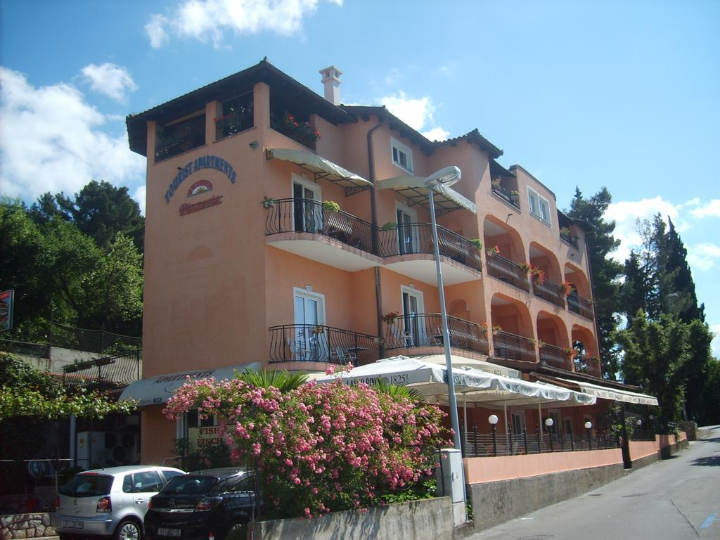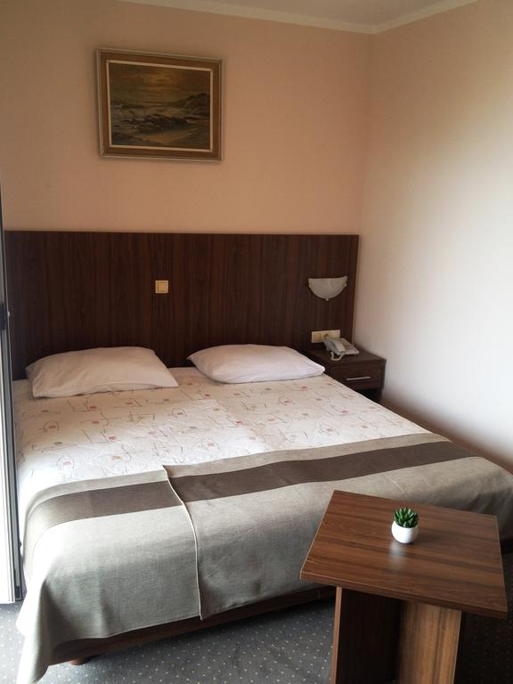

ACTIVITY ROOM

Will be define later.

FOOD

In Rijeka, on the one hand fish and seafood are dominate in the kitchen and on the other hand, Rijeka’s cuisine is known by plenty of hearty-heavy stews, meat and lamb.

Few suggestions regarding the best restaurants in Rijeka:
Charming little bistro La Rose – French and Mediterranean fare
La Rose, Andrije Medulića 8, Rijeka, Croatia

Konoba Feral – Mediterranean and Croatian,local food
Konoba Feral, Matije Gupca 5B, Rijeka, Croatia

À la carte Restaurant Kamov- traditional and modern food
Restaurant Kamov, Grand hotel Bonavia, Dolac 4, Rijeka, Croatia
Restaurant Spagho - Italian food
Ivana Zajca 24a, Rijeka, Croatia

For further inquire, please contact:
Verica Mance
Tel: +385 98 491 882
e-mail address: verica@rss.hr
Maja Berić
Tel: +385 95 901 5373
e-mail address: maja@rss.hr
Facebook: https://www.facebook.com/groups/312019092537760/

