Project description:
Project "All thanks to football" is composed of 4 organisations from Portugal, Poland, Lithuania, Bulgaria. Together there will be 40 participants aged 18-25 (10 people in group), coming from small town or rural areas. The youth exchange will take place in Poronin on 20-27.07 2018. Before we will organise APV for 4 leaders on 30.06-01.07.2018. The project aims at fostering creativity by using sport tools, improving language skills. Thanks to gaining new skills, knowledge and qualifications in the field of creativeness (by workshops, panel discussions, presentations, etc) we will have easier entering adult life and dealing with challenges of present life waiting for european youth. We will conduct exchange activities according to nonformal methods rules by means of discussions, workshops, national evenings, outdoor activities, interacting with local society, promotion activites, etc. We will share the effects of our project with local peers, youth from local school and citizens of Poronin area. Longterm benefits of our projects are: participants being better prepared for adult life, increase of self-confidence, thinking outside of the box, skills of working in international teams, increase of english language skills, increase of awareness of european issues in małopolska region and finally development of organisations composing this project (better relations, new staff, new experience, ideas for future projects and partnerships, etc).

Practical details:
9 youth (age 18-26) participants + 1 leader (no age limit) per group (please maintain gender balance),
All costs (accommodation, food, programme, local accident insurance) covered by organizers.
Travel costs limits per person are:
Portugal - 360 euro; Lithuania - 275 euro, Bulgaria - 275 euro
We can provide a common transport (rented bus) from Kraków to Poronin and return. If you wish to take this bus (recommended) please keep 20 euro from your travel budget or be expected to pay this amount. Otherwise you should arrive to the guesthouse in Poronin for dinner on first day 6pm.
IMPORTANT: Preferably the reimbursement will be done by one bank transfer to sending NGO or any other one account approved by sending NGO. If earlier agreed upon a good reason reimbursement is also possible in cash on place. In any case reimbursement will be done ONLY based on submitting ALL original travel documents for both ways (best if you can provide prints/copies for us) . Please keep ALL travel documents – bills, tickets, boarding passes, invoices, etc. Please plan your travel in advance and inform us. Please consult with us before purchasing your tickets! Please consult us if you need to use other transport than bus, train, plane! Please provide us with travel plan and names of participants at latest 4 weeks prior to the exchange so we can coordinate your arrivals and if required common transport from Krakow airport or city centre to the guest house and to purchase insurance for your stay in Poland. If we don’t have full participant list on time sending organization will be responsible to organize insurance and show to us during exchange as a requirement for travel cost reimbursement. Participants are obliged to have their free European Health Insurance cards – just in case they need free medical help in Poland. The participants are also themselves responsible to get a travel insurance and any medicines they might need. Each team should have at least one laptop/tablet/camera, please take necessary cables so you can up/download working materials.
Exchange venue: Villa Austryjok http://austryjok.pl (all facilities reserved only for our group)
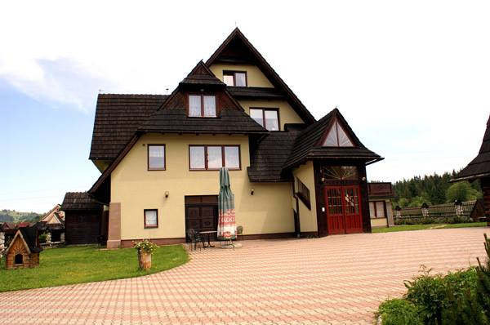
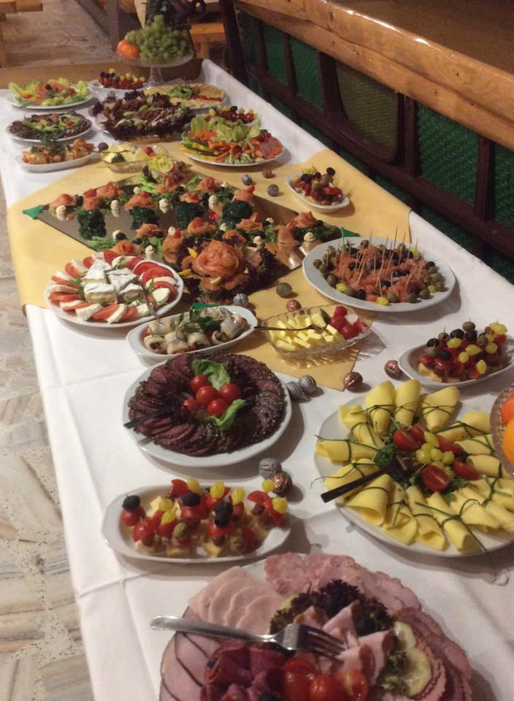
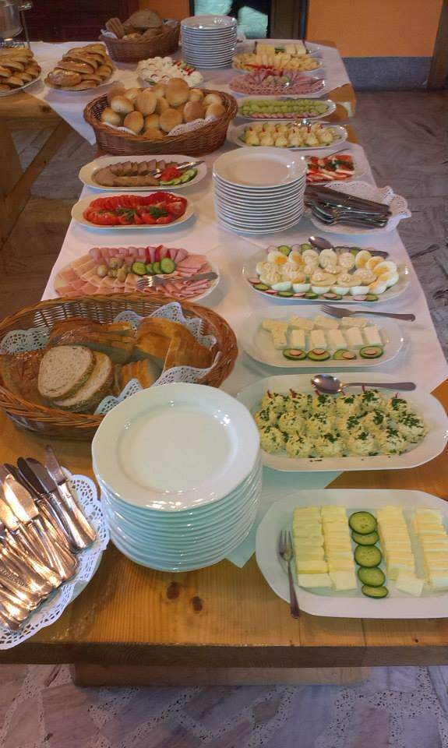
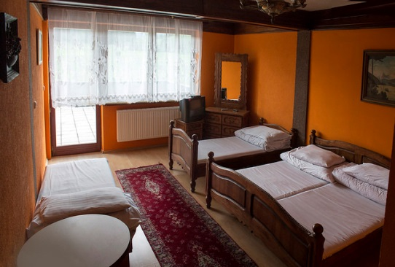
Participants will share 2,3 or 4 people rooms, all with private bathroom and TV. We will have a separate party hut to make disco, barbeque party, etc. 5min walk from our venue there is a shop where you can buy most of things you might need, you can pay with card or polish currency. There is no money exchange in a walking distance so better to exchange currency while in Kraków (but not in the airport where rates are bad). We will serve 3 tasty meals per day, with polish typical cuisine lunch usually. Coffee, tea, water available all day. Please inform us max. 2 weeks prior to exchange if you have any dietary needs

You need to bring your own cosmetics and towel. It is important to take appropriate clothes and shoes, comfortable for workshops and staying indoors but also good shoes, sport dress and something against rain and colder weather outdoors ☺ Please have on your mind that we will go for a mountain walk and have some activities outside. In May it can be very warm and sunny but especially in the mountains it changes quickly and you never know ☺ 

Brief agenda:
Day 1 | arrivals, welcome dinner, introduction, integration evening
Day 2 | History of World Cup included in the poster / movie night with football
Day 3 | workshops in the field of caring for the mental state, good mood, the ability to think positively, taking care of your own body, physical fitness, and the development of individual muscle parties / training on the football field
Day 4 | workshops on charity events and social campaigns run by footballers, football organizations / preparation of a social campaign or charity campaign (in the form of a multimedia presentation)
Day 5 | preparations for the football tournament / going to the mountains
Day 6 | sporty happening
Day 7 | futsal tournament
Day 8 | Departures after breakfast


Of course there will also be some time for sightseeing, mountain trip, buying souvenirs, barbecue, maybe some sport and of course a little relax/party in the evening ☺
Further communication will be done via facebook group (https://web.facebook.com/groups/1869456656438224) so please sign up there and stay in touch with your leaders who stay in direct contact with project co-ordinator from our side.
So let’s be in touch and see you soon in Poland!!

